H.T No
Regulations:
A17


Sreenidhi Institute of Science and Technology
(An Autonomous Institution)
Code No: 6CC04 Date: 11-Feb-2020 (FN)

B.Tech II-Year II-Semester External Examination, Jan/Feb - 2020 (Supplementary)
SIGNALS AND SYSTEMS (ECM)

Time: 3 Hours Max.Marks:75

Note: a) No additional answer sheets will be provided.
b) All sub-parts of a question must be answered at one place only, otherwise it will not be valued.
c) Missing data can be assumed suitably.

Part - A Max.Marks:25

Answer all QUESTIONS.

1. | Infer the relation between Impulse, Step and Ramp signals. | [3M]
2. | Find the Fourier Transform of the periodic signal x(t)= cos(Ω₀t). | [3M]
3. | When a system is said to be memoryless? Give an Example. | [3M]
4. | Define Convolution Sum and Convolution Integral. | [3M]
5. | Define Sampling Theorem and Nyquist Rate. | [3M]
6. | Determine the impulse response for the transfer function H(z) = (2+5z)/(z-8). | [2M]
7. | Determine Fourier series representation of square wave of the interval –T/2 to T/2. | [2M]
8. | Define the Transfer Function of LTI System. | [2M]
9. | Determine the Z–Transform of causal signal defined by x[n]= a^{n}u[n] where 0<a<1 and plot its ROC. | [2M]
10. | Determine the relation between Laplace Transform and Fourier Transform of a signal. | [2M]
Part – B Max.Marks:50
ANSWER ANY FIVE QUESTIONS. EACH QUESTION CARRIES 10 MARKS.

11. | a) | Write short notes on orthogonal vector space and orthogonal signal space. | [5M]
 | b) | Show that the functions sin(nω₀t) and cos(nω₀t) are orthogonal over any interval {t₀ to [t₀+(2π/ω₀)]} for integral values of n and m. | [5M]
12. | a) | Find the Fourier Transform of x(t)=e^{-at}u(t). | [4M]
 | b) | Find the trigonometric Fourier series for the square wave shown in figure  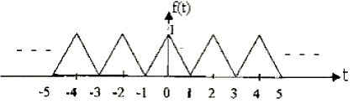 | [6M]
13. | a) | Explain about the Causality and Poly–Wiener Criterion for Physical Realization. | [5M]
 | b) | Determine whether the following systems are linear or non-linear  (i) y(t) = t.x(t) (ii) y[n] = 2x²[n] | [5M]
14. | a) | Obtain the Laplace Transform of the periodic full rectified sine – wave shown in below figure.  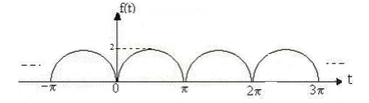 | [6M]
 | b) | Determine the relation between Convolution and Correlation. | [4M]
15. | a) | Write short notes on Impulse Sampling. | [4M]
 | b) | A signal x(t)=2cos400πt + 6cos640πt is ideally sampled at f_{s} = 500Hz. If the sampled signal is passed through an ideal low pass filter with a cutoff frequency 400Hz, what frequency components will appear in the output? Sketch the output spectrum. | [6M]
16. | a) | State and Prove Initial Value Theorem and Final Value Theorems of Z-transform. | [5M]
 | b) | For the below Z-Transform find x[n] using partial fraction method,  X(z)= z(z+10) / (z-1)(z²-8z+20) | [5M]
17. | a) | Explain about Closed set of orthogonal functions. | [4M]
 | b) | Find the Fourier Transform for x(t)=e^{-a|t|} | [3M]
 | c) | Define Impulse Response of LTI System. | [3M]
18. | a) | Using Convolution integral find the convolution of the signal x₁(t) = e^{-t}u(t) and  x₂(t) = e^{-2t}u(t) | [4M]
 | b) | Explain about Flat Top Sampling. | [3M]
 | c) | Explain the Properties of Region of Convergence for Z - Transform. | [3M]

-- 00 -- 00 –

